s

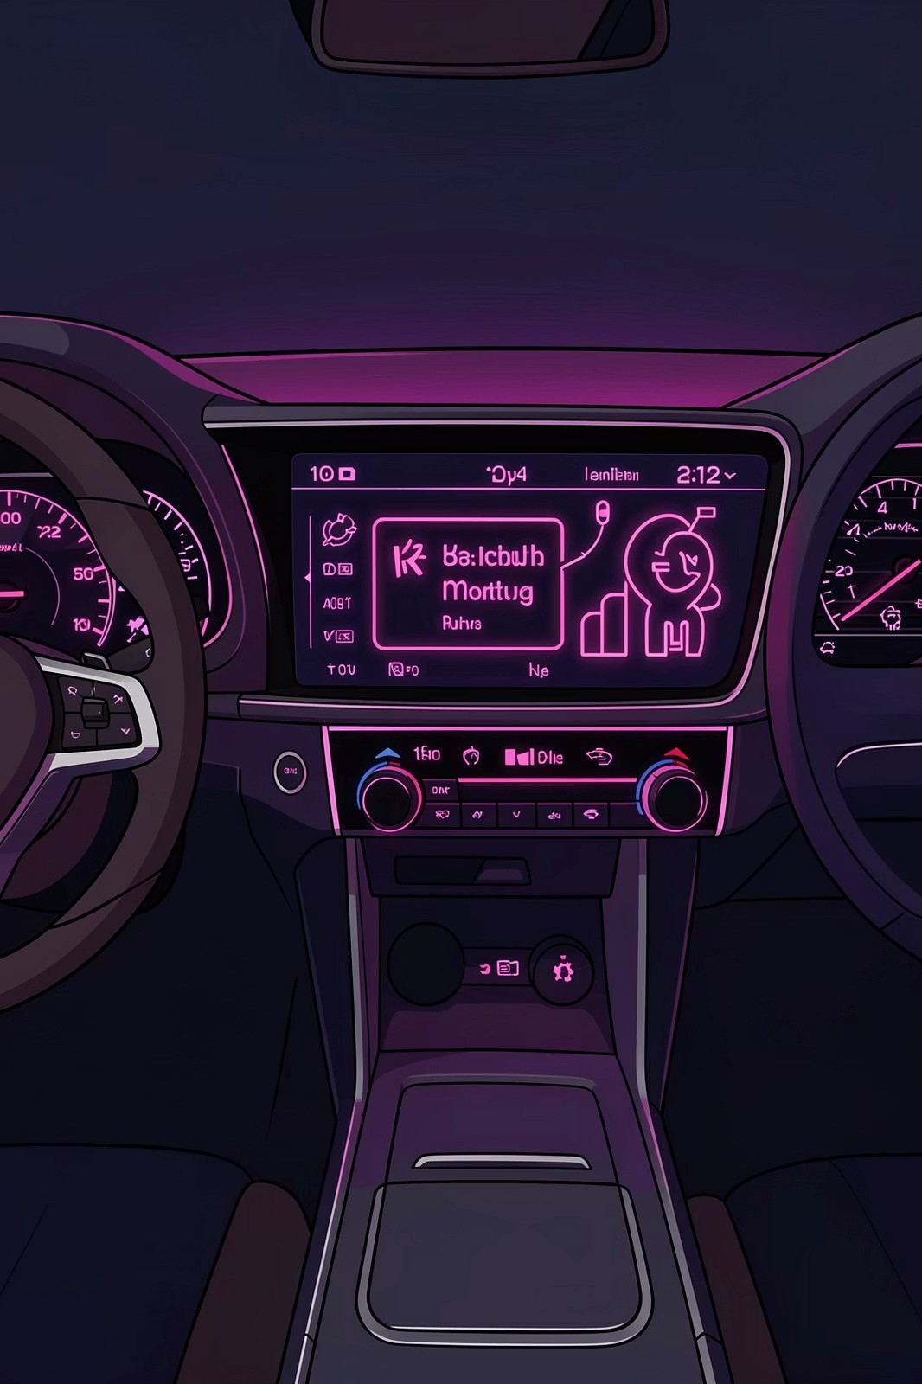

**Vehicle Health Tracker**

Mohammed Haaris – 2410030321  
Syed Adnaan- 2410030371

Bharat Kumar- 2410030137

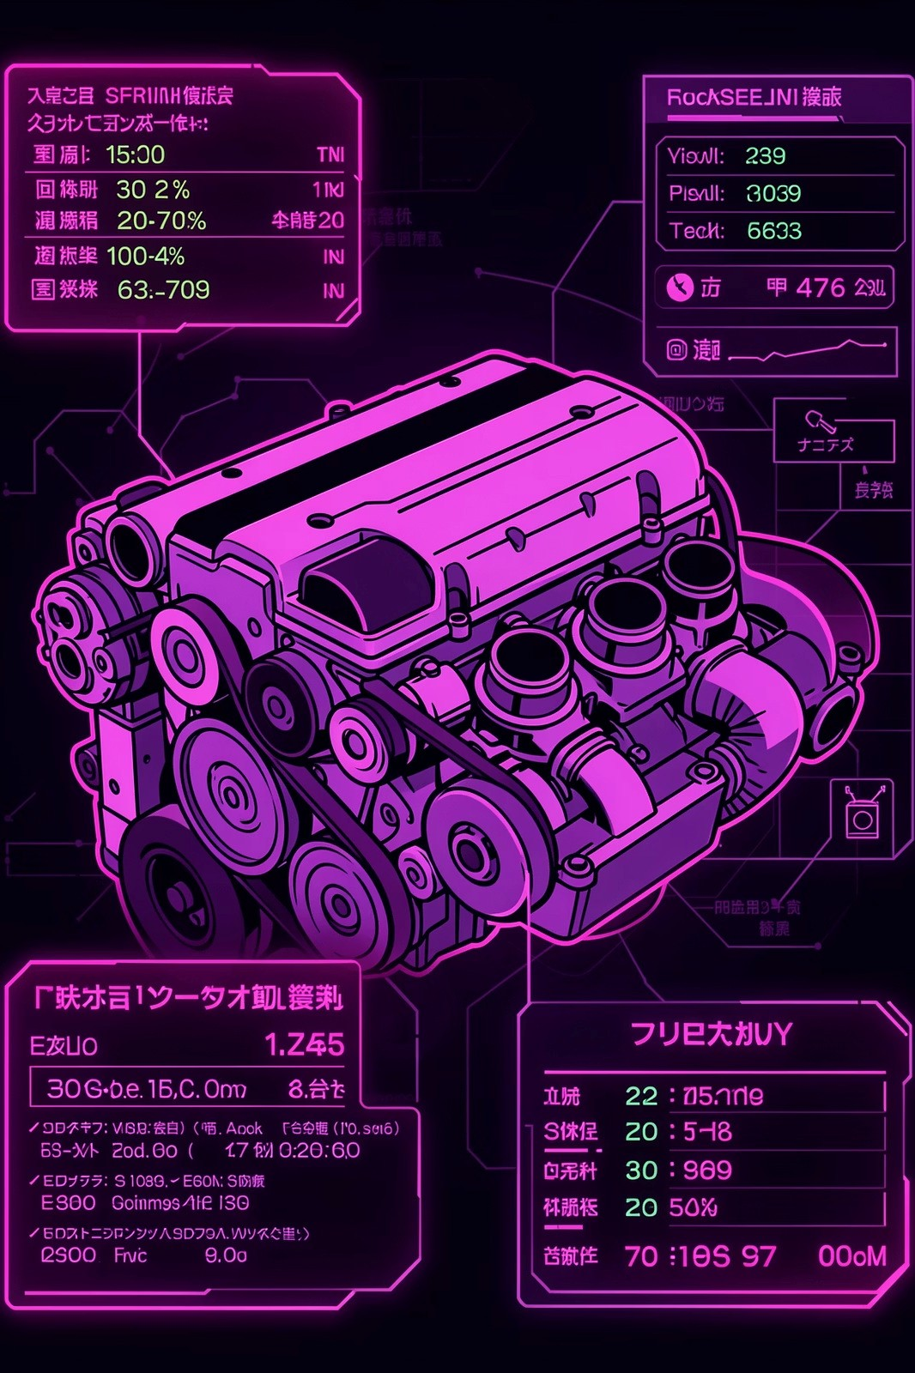

**Real-Time Monitoring: Your**

**Vehicle's Digital Guardian**

**Continuous Health**

**Tracking**

Monitors engine health, tire

pressure, oil levels, and battery

status automatically—no manual

checks required

**Intelligent Analysis**

GPS trackers analyze engine

performance patterns and alert

you before breakdowns occur,

keeping you ahead of problems

**Live Dashboard**

View all vital metrics in real-time through an intuitive interface that

makes vehicle health easy to understand

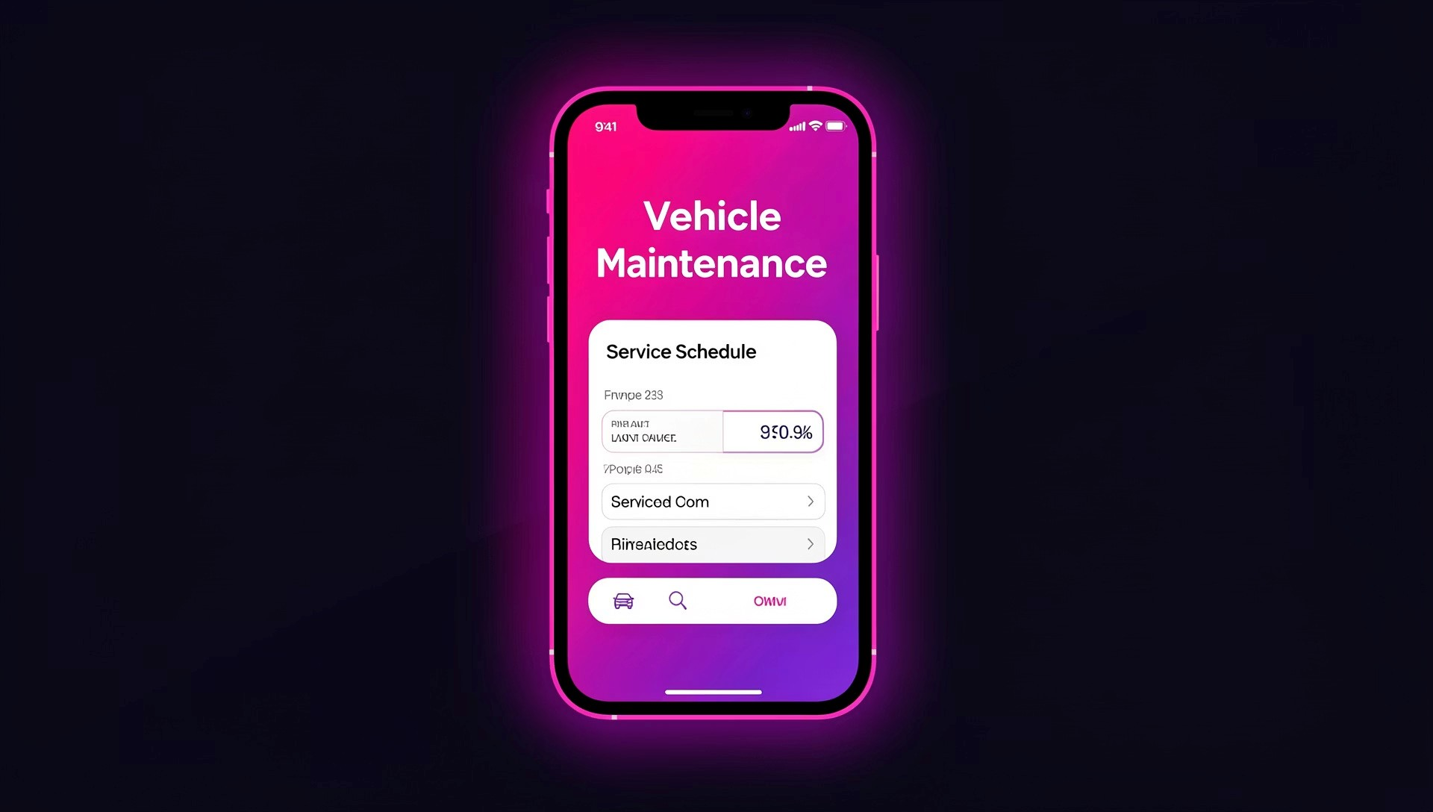

**Maintenance**

**Alerts: Never**

**Miss a Service**

**Again**

Automated reminders based on mileage

and diagnostics ensure your vehicle gets

the care it needs exactly when it needs it—

from oil changes to tire rotations.

**Real-World Success**

Guidepoint Systems' app notifies owners

instantly of recalls and maintenance

needs, preventing minor issues from

becoming major expenses. Early

intervention saves thousands in costly

repairs.



**How Real-Time Data Transforms Vehicle Care**



**Instant DTC Alerts**

Diagnostic Trouble Codes are identified

immediately, reducing downtime and

preventing expensive repair bills

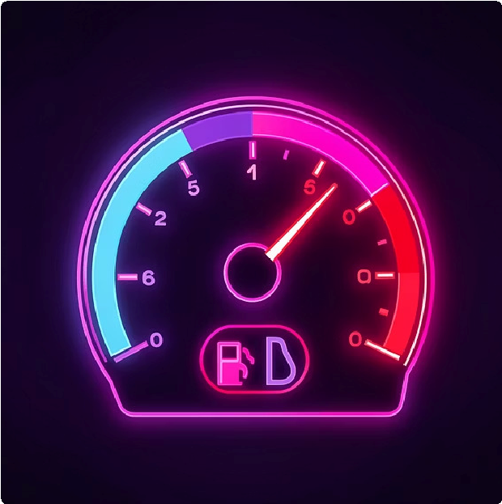

**Fuel Monitoring**

Track consumption patterns to identify

inefficiencies and optimize your vehicle's

fuel economy

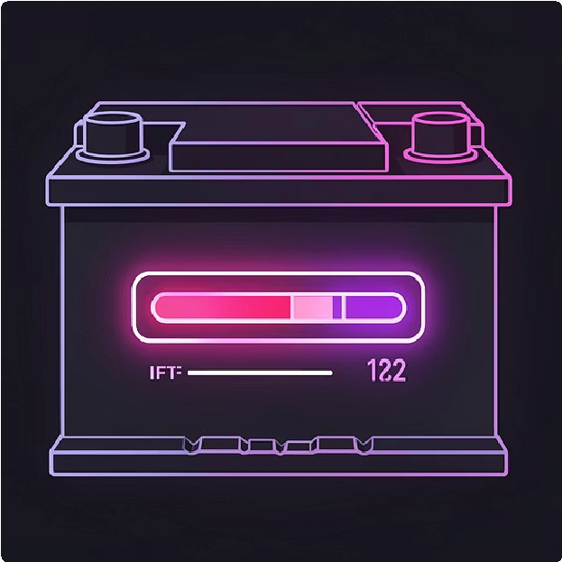

**Battery Health**

Monitor battery performance and receive

warnings before you're stranded with a

dead battery



**Improving Road Safety Through Proactive**

**Monitoring**

**Early Detection Saves Lives**

Mechanical failures are a leading cause of accidents. Vehicle health trackers identify malfunctions before they become dangerous,

catching issues with tire pressure, brake systems, and critical components.

**20**

**%**

**Fewer Accidents**

Fleets using health trackers report significant reductions in accident rates annually



**The Technology Behind Vehicle Health Trackers**

**Vehicle**

**Sensor**

**Network**

**OBD-II Port**

Central vehicle data

gateway

**Cloud Platform**

Aggregates telemetry

for analysis

**Tire Pressure**

**Monitors**

Real-time pressure

status

**GPS Module**

Location and speed

data

**Engine Sensors**

RPM, temp,

diagnostics

**Battery Sensors**

Voltage and charge

health

**Comprehensive Data Collection**

Vehicle health trackers integrate

seamlessly with onboard diagnostics

OBD-II) systems and GPS technology to

(

gather comprehensive performance data.

**Real-World Example**

Samsara's Vehicle Gateway combines real-

time location tracking with engine

diagnostics, creating a complete picture of

vehicle health and utilization for optimal

fleet management.



**User Experience: Simplifying Vehicle Management**

**Mobile-First Design**

Intuitive mobile apps put complete

vehicle management in your pocket—

schedule services, view detailed

maintenance history, and receive instant

recall updates wherever you are.

**Fleet Management Success**

Fleet managers leverage automated

maintenance workflows to slash

operational costs, eliminate paperwork,

and keep vehicles running at peak

performance with minimal downtime.

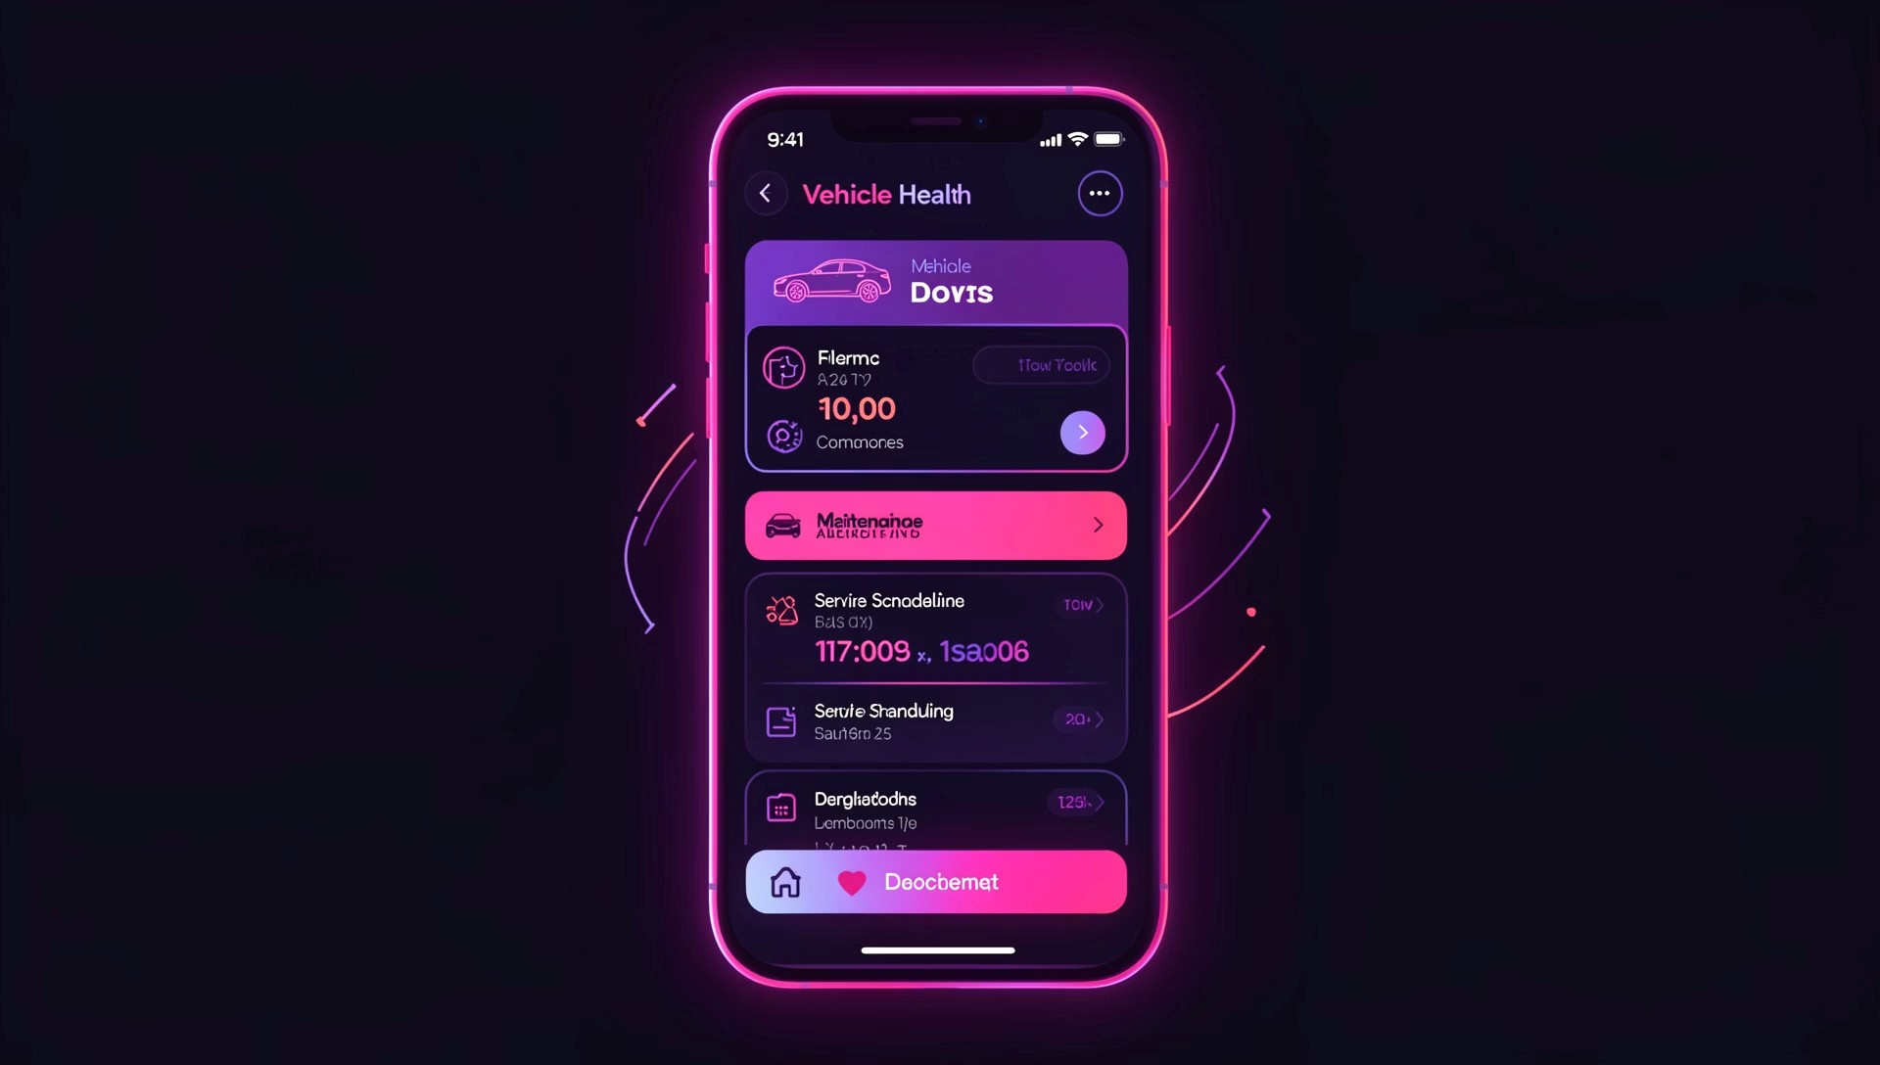

**Business Impact: From**

**Individual Owners to Large**

**Fleets**



**Dealership Revenue Growth**

Proactive customer engagement through maintenance reminders

increases service department revenue and builds lasting customer

relationships



**Extended Asset Life**

Fleet operators significantly improve vehicle longevity while reducing

unexpected breakdowns that disrupt operations and drain budgets



**Efficiency Gains**

Real-time monitoring delivers 15-20% improvements in fuel efficiency

across fleets, translating to substantial cost savings



**Challenges and Future Directions**

**Compatibility**

Ensuring seamless

integration across diverse

vehicle makes, models,

and years

**Data Privacy**

Protecting sensitive

vehicle and location data

while maintaining

functionality

**The Road Ahead**

AI-powered predictive maintenance is revolutionizing the

industry, using machine learning to forecast issues before they

occur. Integration with electric vehicle systems opens new

possibilities for battery optimization and charging

management.



**Drive Smarter, Safer, and**

**More Efficiently**

Vehicle Health Trackers empower owners with real-time insights and timely

alerts that transform the driving experience—enhancing safety, reducing

costs, and providing peace of mind on every journey.

**1**

**Know Your Vehicle**

Complete visibility into health and performance

**2**

**Stay Proactive**

Address issues before they become problems

**3**

**Save Money**

Reduce repair costs and improve efficiency

**Embrace vehicle health technology today for a safer**

**tomorrow**

